**CRAFTING VALUABLE SPRINT GOALS**

**by Tobe Nneji**

**BREAK-OUT ACTIVITY WORKSHEET**

**Scenario:**

The product being developed is intended to make a set of related internal and external HR-products accessible through a single web-based platform. This will range from software for registration to invoicing, and from recruitment to personnel planning. The new product is to simplify the existing process which has multiple product sign-on and dashboards into one platform product with a single sign-on, dashboard and tracking capability. Your Scrum Team is dedicated to this product vision, and has all the technical skill and tools necessary to deliver. The Product Owner has articulated the various PBIs and has recommended sprint goals for the first 3 sprints. At kick-off, your team agreed to ship to production at the end of each sprint.

**Your Tasks:**

1. Go over the user stories and Sprint Goals, and match the stories to the goal that it most closely aligns towards.
2. Based on the goals, prioritize the Product Backlog.

**Sprint Goals:**

* A visitor can see frequently used products and their detail summary on the web homepage
* Set up deployment pipeline & release an empty site to production
* A visitor can order and pay for a product, and receive an order confirmation

**User Stories:**

1. Set up a distributed service bus (NServiceBus)
2. Before deploying to production, automatically run integration tests on API
3. Create HTML-based style guide based on visual design
4. Configure Bootstrap for basic styling elements in the homepage
5. Create a sticky-based Sprint Backlog and Product Backlog on the wall in the team-room
6. Encrypt user-sensitive information in order - email, address, credit card details
7. Integrate and transfer to outside payment platform – PayPal, ApplePay or GooglePay
8. Set up servers for the production environment (including database)
9. Set up a build server to build commits, run unit tests and compile deployment packages
10. Identify the 5 most used products internal products and gather product details & images
11. Implement a pop-up bubble, where visitors can see details of a selected product after clicking ‘details’
12. Test homepage in modern browsers, and desktop and mobile device formats
13. Allow customers to pay for their order by credit card, PayPal, ApplePay or GooglePay
14. Remember failed payments in an audit log so we can track potential abuse
15. When an order is completed, auto-generate a confirmation code
16. When a confirmation code is generated, send order to the sales department and the code to the user’s email address
17. When a user purchases a product, record their license in a separate service
18. Before deploying to production, patch security and compliance
19. Test integration and API call to sales department
20. Before deploying to production, automatically back-up the database
21. Implement algorithm to automatically order products from internal to external
22. Set up and seed table for Products in the database with selected products
23. Set up an empty API that connects to any empty database
24. Identify the 20 most used products internal products and gather product details & images

|  |  |
| --- | --- |
| **Sprint 1** | |
| **Sprint Goal** |  |
| **User Stories** |  |
|  |
|  |
|  |
|  |
|  |
|  |
|  |
|  |

|  |  |
| --- | --- |
| **Sprint 2** | |
| **Sprint Goal** |  |
| **User Stories** |  |
|  |
|  |
|  |
|  |
|  |
|  |
|  |
|  |

|  |  |
| --- | --- |
| **Sprint 3** | |
| **Sprint Goal** |  |
| **User Stories** |  |
|  |
|  |
|  |
|  |
|  |
|  |
|  |
|  |

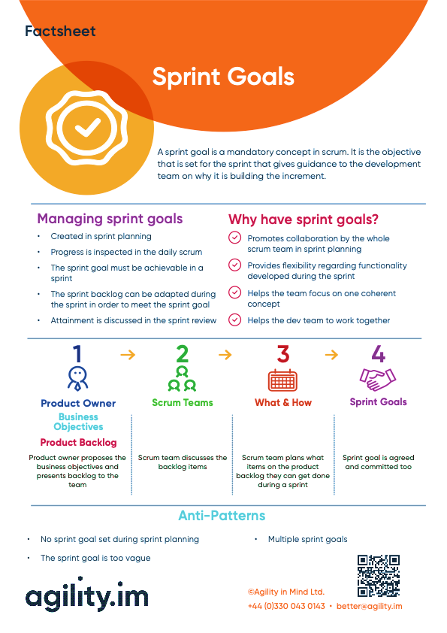 source: <https://agility.im/frequent-agile-question/what-is-a-sprint-goal/>